

**Introduction**:

In this section, we will learn how to deploy our dockerize applications. So we will take the same application we have been working with and put it in the cloud.

We will talk about,

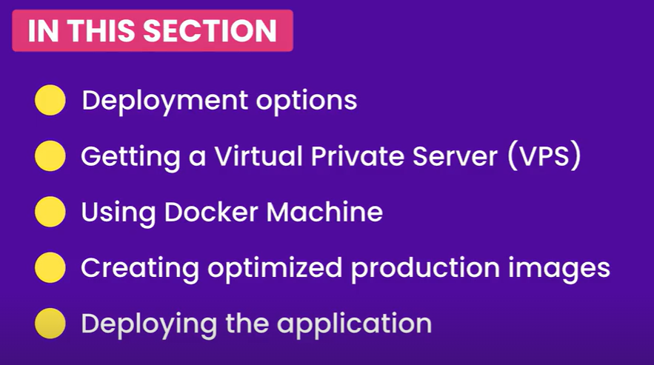

**Deployment options**:

To deploy our docker as applications we have two options,

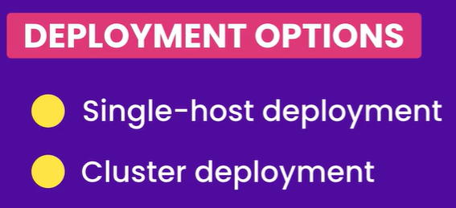

We can deploy our application to a *single host* or as a *cluster*, which means a group of servers.

As you might guess, deploying to a single host is really easy but the problem with single host deployment is that *if our server goes offline our application will not be accessible and also if our application goes rapidly and we get 100s or 1000s of users, a single server is not able to handle that load, that’s why we use* ***clusters***.

So with clusters we get high availability and scalability.

For clusters we need special tools called *orchestration tools*. Docker has its own orchestration tools built into it called ***Docker swarm*** (*but it’s not that popular*) most people these days use another tool called ***Kubernetes*** which is a google product.

Since ***Kubernetes*** is too wide and fairly complex for the scope of this course, therefore here we will focus on single host deployment.

**Getting a virtual private server**:

To deploy our application we need a virtual private server or VPS. There are a ton of options to get a VPS.

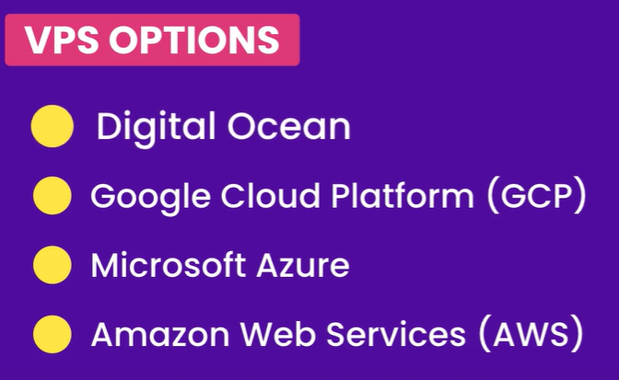

Digital ocean is the simplest one and most beginner friendly one and as we go down this list we get more and more features but at the cost of complexity.

Here we will use Digital ocean.

**Installing Docker machine**:

Once we have a server, we need to use a tool called *Docker Machine*, to talk to the docker engine on that server.

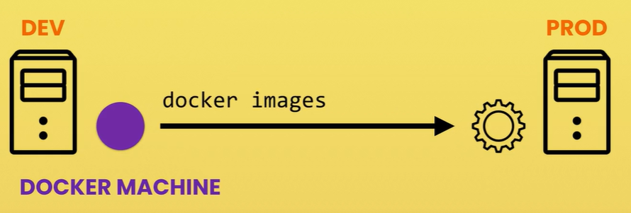

So this way we can execute commands in our terminal and our commands will be sent to the docker engine on our server.

Head over to github.com/docker/machine/releases/

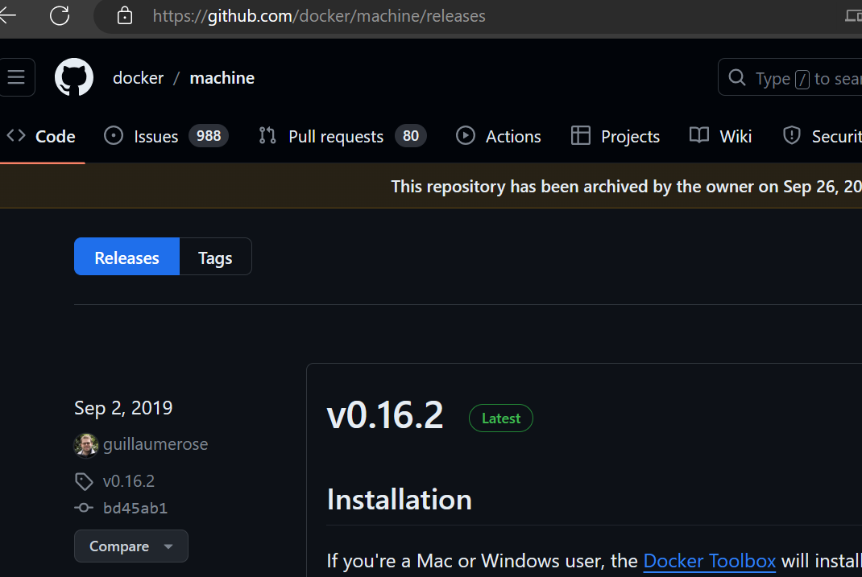

Instructions for installation on windows,

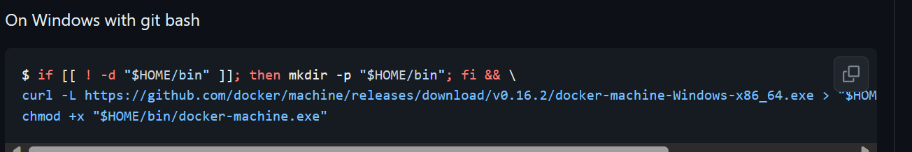

Have not installed yet…